**PROGRAMMING THE FUTURE**

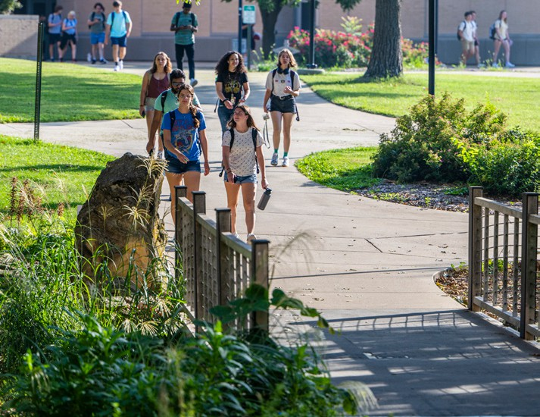

**GRADUATE PROGRAMS**

**IN-PERSON**

**DELIVERY:** Fall and Spring

**DEGREES OFFERED:**

Thesis MS, Non-Thesis MS, PhD

**RESEARCH AREAS:**

* Cyber Security
* Cyber-Physical Systems
* Data Science and AI (Artificial Intelligence)
* High-Performance Computing
* IoT and Cloud Computing
* Mobile Computing and Wireless Networks
* Theory and Quantum Computation

**GRADUATE COORDINATORS:**

Sanjay Madria (Thesis MS, PhD), [**madrias@mst.edu**andRicardoMorales](mailto:madrias@mst.eduandRicardoMorales) (Non-Thesis MS), [**ricardom@mst.edu**,](mailto:ricardom@mst.edu) 573-341-4491, [**csgradcoord@mst.edu**](mailto:csgradcoord@mst.edu)

Computer science is in critical demand and the

core of our modern world.

Are you interested in programming self-driving cars or learning how to prevent the next cyber-attack? Is computer networking, creating mobile apps or data-mining of special interest to you? Consider digging deeper into your own skill set and creativity by joining the first — and best — computer science program in the state.

As a graduate student, you’ll do research alongside expert computer science faculty in the areas of distributed systems, machine learning, artificial intelligence, high performance computing, cyber security and IoT computing. You could also choose the interdisciplinary route, doing research with faculty in various engineering disciplines.

**LIKE WHAT YOU SEE? TAKE THE NEXT STEP.**

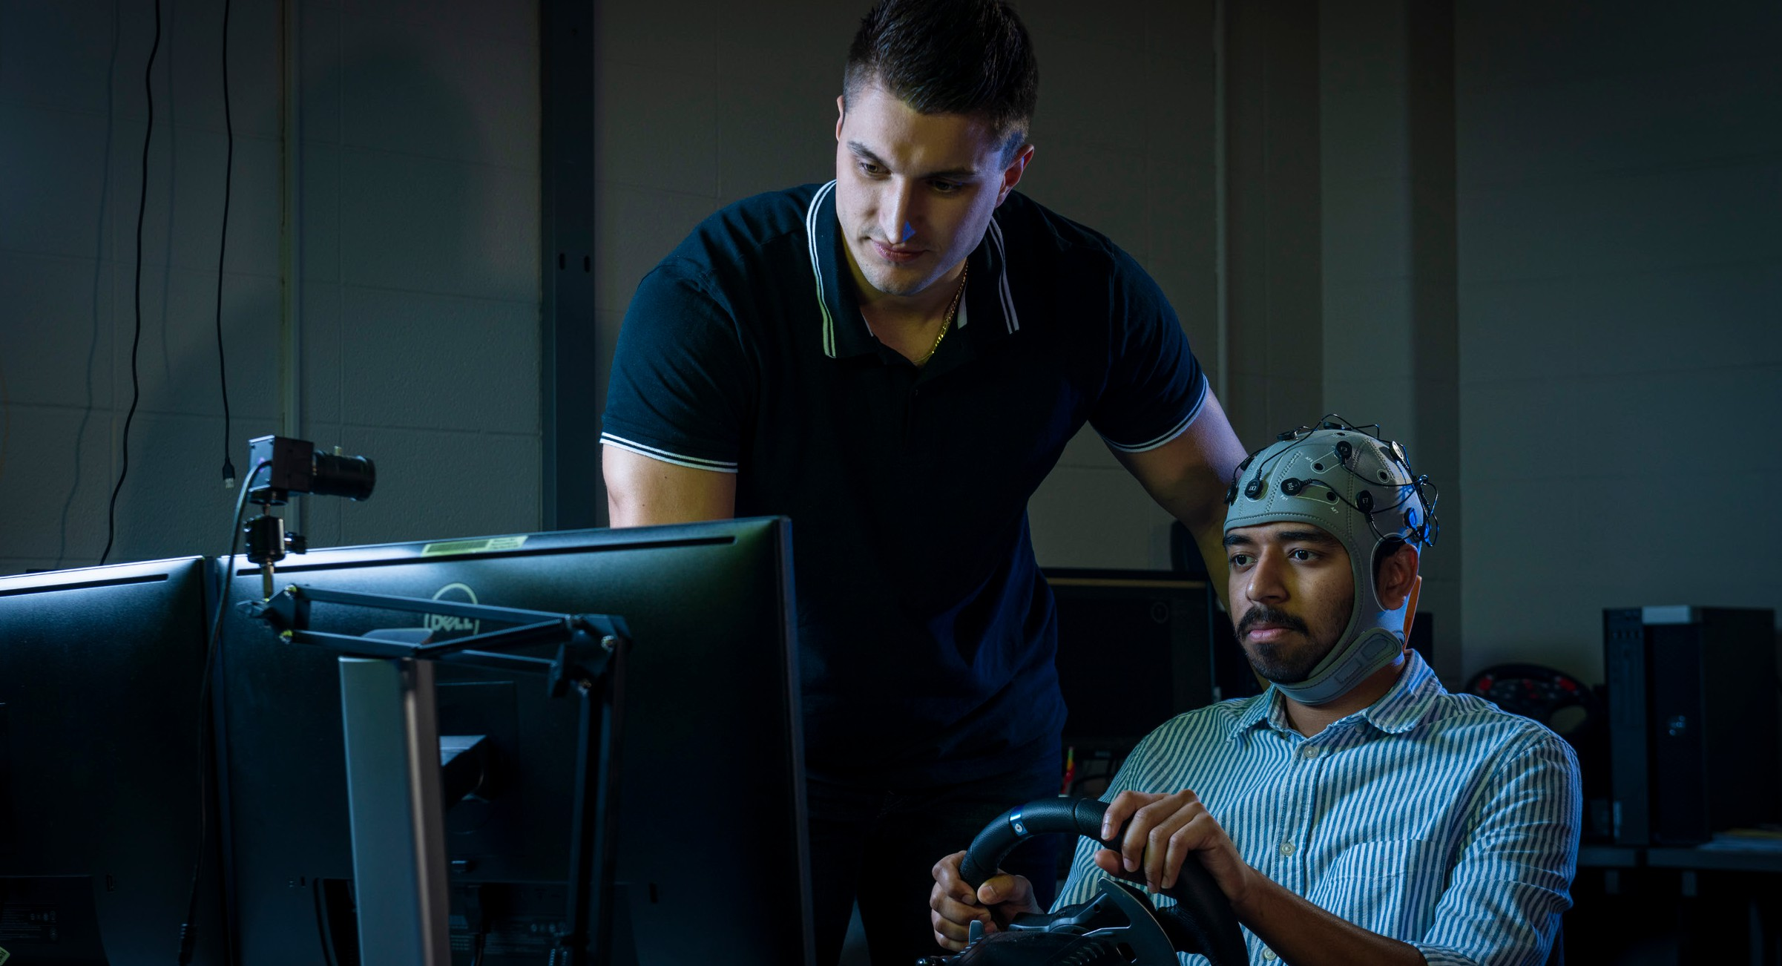

COMPUTER SCIENCE

**COLLEGE OF ENGINEERING AND COMPUTING**

## Level up in your field and gain advanced expertise with a graduate degree from Missouri S&T. Scan

the QR codes to get started.

#### REQUEST INFORMATION

Let us tell you more.

#### APPLY NOW

Make S&T part of your equation.

**DEGREE REQUIREMENTS**

**Admission Requirements**

### Documents Needed

* Online application
* Resume/CV (none for Certificate)

## **Master of Science (Non-Thesis)**

Total of 31 hours of graduate course work required

* CS 5200 - Algorithms
* 1 semester of seminar course CS 6010
* A minimum of 9 hours of 6000-level CS lecture courses
* 9 to 15 hours of graduate CS lecture courses at or above the 5000 level
* A minimum of 3 hours and a maximum of 6 hours of out-of-department courses to be selected from an approved list

## **Master of Science (Thesis)**

Total of 31 hours of graduate course work/ thesis credit required, including:

* CS 5200 - Algorithms
* 1 semester of seminar course CS 6010
* A minimum of 9 hours of 6000-level CS lecture courses
* A minimum of 9 hours of 6000-level CS lecture courses
* 6 to 9 hours of thesis credit CS 6099.

## **Doctor of Philosophy**

Total of 72 hours required

* 15 hours 6000 level CS lecture courses
* Three semesters of seminar course CS 6010
* CS 5200 – Algorithms
* At least 24 hours of research
* At least 24 hours of courses
* Other courses prescribed by Ph.D. Committee
* Qualifier exam
* Research Readiness Presentation
* Publication Requirement for PhD (Effective Fall 2018)
* Before dissertation defense, two full research papers (e.g., not short,

abstract or poster papers), substantially related to the dissertation, must be accepted for publication in Ph.D. committee approved reputable and peer-reviewed conferences or journals

* In egregious cases, the GPPC can reject a conference or journal for not being reputable.

Students who do not hold a master’s degree must complete at least 72 hours of graduate credit. The plan of study (Form 5/5-A) must include a minimum of 36 credit hours of 4000-, 5000-, and

6000-level lecture courses (1000/2000-level courses cannot be included). Fifteen credit hours of the required coursework are recommended from the group of 6000-level lecture courses. A minimum of 24 credit hours of graduate research is required.

* Statement of purpose
* Letters of recommendation
  + Ph.D.: 3
  + M.S. thesis: 2
  + M.S. non-thesis: 2
  + Certificate: 0
* Official transcripts from all institutions attended

### GRE

* Verbal + Quantitative: 300
* Analytical Writing: 3.0

### English Proficiency Scores (International Students)

* IELTS 6.5 | TOEFL 80
* PTE 58 | Duolingo 115

### Undergraduate Coursework

* Minimum undergraduate GPA: 3.0
* Algorithms
* Computer Organization and Design/Computer Architecture
* Data Structures (Computer Programming II)
* Database Management Systems
* Discreet Mathematics/ Mathematics for Computing/Computation
* Operating Systems
* Software Engineering

University Funding

*For specific criteria for these scholarships, visit* ***sfa.mst.edu****.*

# Provost’s Master’s Merit-Based Scholarship (Domestic)

This renewable scholarship provides financial support for eligible domestic, non-thesis master’s, out-of-state students. The total value is $10,000.

# Provost’s Master’s Merit-Based Scholarship (International)

This renewable scholarship provides financial support for eligible non-thesis master’s international students. The total value is $20,000.

# CEC Dean’s

**Master’s Scholarship**

This renewable scholarship provides $2,000 for eligible domestic, non-thesis master’s, out-of-state students who

are enrolled in specific degree programs within the College of Engineering and Computing (CEC).

# Kummer I&E Doctoral Fellows

Fellows receive a Graduate Research Assistantship position on campus, a fellowship

(paid out semesterly), and tuition remission for required coursework for up to four years. You must have a faculty recommender.

Updated: 1/1/2024